**PATFIN HIGH SCHOOL, AKESAN, LAGOS STATE.**

**FIRST TERM EXAMINATION [ 2018 / 2019 ]**

**CLASS : K . G 1**

**NAME : ______________________________________ SUBJECT: BASIC SCIENCE**

**INSTRUCTION : ANSWER CORRECTLY DURATION : 1 HOUR**

1. Is a snake bite painful ? ____________ [ Yes / No ]
2. Do you have to move close to a dangerous object? ______ _ [ Yes / No ]
3. You should not play with sharp objects. True / False
4. Mention three sharp objects you know

_____________ ________________ ________________

1. A safe environment is a place free from fears and ___________. [a] Dangers [b] Biscuit [c] Pains

**PATFIN HIGH SCHOOL, AKESAN, LAGOS STATE.**

**FIRST TERM EXAMINATION [ 2018 / 2019 ]**

**CLASS : K . G 1**

**NAME : ______________________________________ SUBJECT: SOCIAL - HABITS**

**INSTRUCTION : ANSWER CORRECTLY DURATION : 1 HOUR**

1. Every child has a name. [ Yes / No ]
2. Can you tell me your name?

My name is _______________________________.

1. You are from which country? [a ] Nigeria [b ] Cote De Voir [b] Niger [c] Chad
2. Is it good for children to beg? [ Yes / No ]
3. You must not listen to strangers. [True / False]

**PATFIN HIGH SCHOOL, AKESAN, LAGOS STATE.**

**FIRST TERM EXAMINATION [ 2018 / 2019 ]**

**CLASS : K . G 1**

**NAME : ______________________________________ SUBJECT: HEALTH - HABITS**

**INSTRUCTION : ANSWER CORRECTLY DURATION : 1 HOUR**

1. Is it good to eat when you are sick? [ Yes / No ]
2. Immunization is taken to prevent childhood ___________ . [a ] Fever [b] Stubbornness [c] Diseases.
3. I can use drugs anyhow . [ Yes / No ]
4. I can drink any water I find . [True / False]
5. Examples of childhood diseases are

[a] ________________ [b] ________________ [c] ________________

**PATFIN HIGH SCHOOL, AKESAN, LAGOS STATE.**

**FIRST TERM EXAMINATION [ 2018 / 2019 ]**

**CLASS : K . G 1**

**NAME : ______________________________________ SUBJECT: CIVIC - EDUCATION**

**INSTRUCTION : ANSWER CORRECTLY DURATION : 1 HOUR**

1. I can hear with my ____________ [a] Nose [b] Shoes [c] Eyes
2. I can talk with my _________________
3. I am a _______________. [ Girl / Boy ]
4. A good child must always fight in the class. [ Yes / No ]
5. I should always ____________ my school rules and regulations . [a] Disobey [b] Obey [c] Abuse .

**PATFIN HIGH SCHOOL, AKESAN, LAGOS STATE.**

**FIRST TERM EXAMINATION [ 2018 / 2019 ]**

**CLASS : K . G 1**

**NAME : ______________________________________ SUBJECT: FOOD AND NUTRITION**

**INSTRUCTION : ANSWER CORRECTLY DURATION : 1 HOUR**

1. What makes you grow? [a] Water [b] Food [c] Sleep.
2. Fish contains Protein . [ True / False ]
3. Carbohydrate is an energy giving food. [ True / False ]
4. I must _________ my hands before and after eating. [a] Fold [b] Wash [c] Soak
5. Is it good to eat food that has fallen on the floor ? [ Yes / No ]

**PATFIN HIGH SCHOOL, AKESAN, LAGOS STATE.**

**FIRST TERM EXAMINATION [ 2018 / 2019 ]**

**CLASS : K . G 1**

**NAME : ______________________________________ SUBJECT: CHRISTAIN RELIGIOUS STUDIES**

**INSTRUCTION : ANSWER CORRECTLY DURATION : 1 HOUR**

1. Who made the animals ? [ Satan / Animals ]
2. List three[3] animals that God made below

[a] ________________ , [b] ________________ , [c] _______________

1. Who killed Abel ?

________________________________

1. The first man and woman God created were ?

___________________ and __________________.

1. Plants God made are

[a] ________________ , [b] ________________ , [c] _______________

**PATFIN HIGH SCHOOL, AKESAN, LAGOS STATE.**

**FIRST TERM EXAMINATION [ 2018 / 2019 ]**

**CLASS : K . G 1**

**NAME : ______________________________________ SUBJECT: KNOWLEDGE OF THE WORLD**

**INSTRUCTION : ANSWER CORRECTLY DURATION : 1 HOUR**

1. The President of Nigeria is

____________________________________________________________.

1. Who is the Governor of Lagos State ?

**______________________________________________________________________________.**

1. The Nigerian flag is Green, White and ______________. [a] Black [b] Green .
2. Recites the States and their Capitals in Nigeria
3. The name of my school is

________________________________________________________________________.

**PATFIN NURSERY AND PRIMARY SCHOOL, AKESAN, LAGOS STATE.**

**THIRD TERM EXAMINATION [ 2017 / 2018 ]**

**CLASS : K . G 1**

**NAME : ______________________________________ SUBJECT: P . H . E**

**INSTRUCTION : ANSWER CORRECTLY DURATION : 1 HOUR**

1. Jog on a spot
2. Spin around 5[Five] times
3. Jump up and clap in the air [ 10 Times ]
4. Hop on one leg [10 Times ]
5. Fly like an airplane

**PATFIN NURSERY AND PRIMARY SCHOOL, AKESAN, LAGOS STATE.**

**THIRD TERM EXAMINATION [ 2017 / 2018 ]**

**CLASS : K . G 1**

**NAME : ______________________________________ SUBJECT: RHYMES**

**INSTRUCTION : SING ALONG DURATION : 1 HOUR**

1. Whine the bobbin ___________

Whine the __________ knob

Pull, Pull, _________, __________, __________

Whine it ____________ again

________, ________ up again

Pull, Pull, _________, __________, __________

1. Point to the __________

Point to the __________

____________ _________ the window

Point _______ _________ door

Put _________ hands ________

1, 2, 3, __________ __________ hands

__________ __________ kneels.

1. Little Miss __________

Sat on her ___________,

Eating her _______ and ____________,

Down ___________ a little ____________,

Who sat _______ besides her,

And sent __________ _______ Muffet away.

1. Bean _________ is _______

Bean porridge is _________

Bean porridge is ______ the ______  
Three _______ old

Some ______ it hot

Some _____ it cold

Some ________ it in the ______

Three days _______

**PATFIN NURSERY AND PRIMARY SCHOOL, AKESAN, LAGOS STATE.**

**SECOND TERM EXAMINATION [ 2017 / 2018 ]**

**CLASS : K . G 1**

**NAME : ______________________________________ SUBJECT: NUMBER – WORK**

**INSTRUCTION : ANSWER ALL QUESTIONS DURATION : 1 HOUR**

1. Oral counting of numbers **1 – 50**
2. Count and write numbers **1 – 40**

|  |  |  |  |  |  |  |  |  |  |
| --- | --- | --- | --- | --- | --- | --- | --- | --- | --- |
|  |  |  |  |  |  |  |  |  |  |
|  |  |  |  |  |  |  |  |  |  |
|  |  |  |  |  |  |  |  |  |  |
|  |  |  |  |  |  |  |  |  |  |

1. Fill in the gaps **1 – 40**
2. _______ 3 _______ 4 _______ 5 _______ 7 _______ 9 _______ 11 _______ 13 _______ 15 _______ 17 _______ 19 _______ 20 _______ 22 _______ 24 _______ 26 _______ 28 _______ 30 _______ 32 _______ 34 _______ 36 _______ 38 _______ 40.
3. Match same numbers

**35 40**

**36 39**

**37 38**

**38 37**

**39 36**

**40 35**

1. Circle the bigger objects

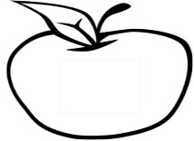 

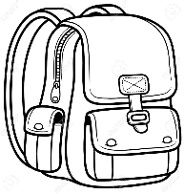 

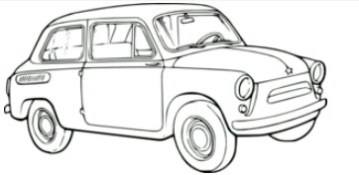 

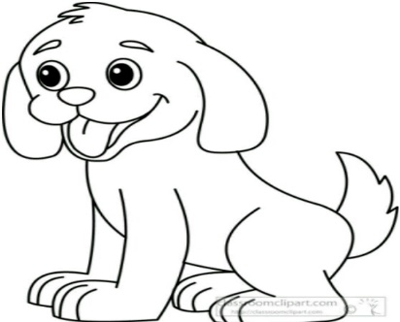 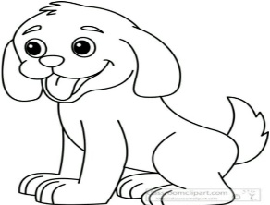

**PATFIN NURSERY AND PRIMARY SCHOOL, AKESAN, LAGOS STATE.**

**THIRD TERM EXAMINATION [ 2017 / 2018 ]**

**CLASS : K . G 1**

**NAME : ______________________________________ SUBJECT: LETTER – WORK**

**INSTRUCTION : ANSWER ALL QUESTIONS DURATION : 1 HOUR**

1. Sound letters **a – t** orally
2. Read and write letters **A – T**

|  |  |  |  |  |  |  |  |  |  |
| --- | --- | --- | --- | --- | --- | --- | --- | --- | --- |
|  |  |  |  |  |  |  |  |  |  |
|  |  |  |  |  |  |  |  |  |  |

1. Fill in the gaps **A – T**

A ________ C ________ E ________ G ________ I ________ K ________ M ________ 0 ________ Q ________ S

1. Match same letters

**A E**

**B D**

**C C**

**D B**

**E A**

1. What shapes are these ?

_____________________

________________________

____________________

**PATFIN NURSERY AND PRIMARY SCHOOL, AKESAN, LAGOS STATE.**

**THIRD TERM EXAMINATION [ 2017 / 2018 ]**

**CLASS : K . G 1**

**NAME : ______________________________________ SUBJECT: SHAPES AND COLORS**

**INSTRUCTION : INDENTIFY AND COLOUR ALL DURATION : 1 HOUR**

* **Identify** and **Color** the following **Shapes**

What Shape is this ?

It is a ________________ .

Color it **Green**.

What Shape is this ?

It is a ________________ .

Color it **Red**.

T This is a ________________.

Color it **Blue**

This is a ________________.

Color it **Yellow**

This is a ________________.

Color it